CS 255 System Design Document Template

This template lays out all the different sections that you need to complete for Project Two. Each section has guidance to prompt your thinking. You will need to continually reference the interview transcript as you work to make sure that you are addressing your client’s needs. There is no required length for the final document. Instead the goal is to complete each section based on what your client’s needs are. Remove this note when you are finished, and replace all bracketed text with the relevant information.

UML Diagrams

UML Use Case Diagram
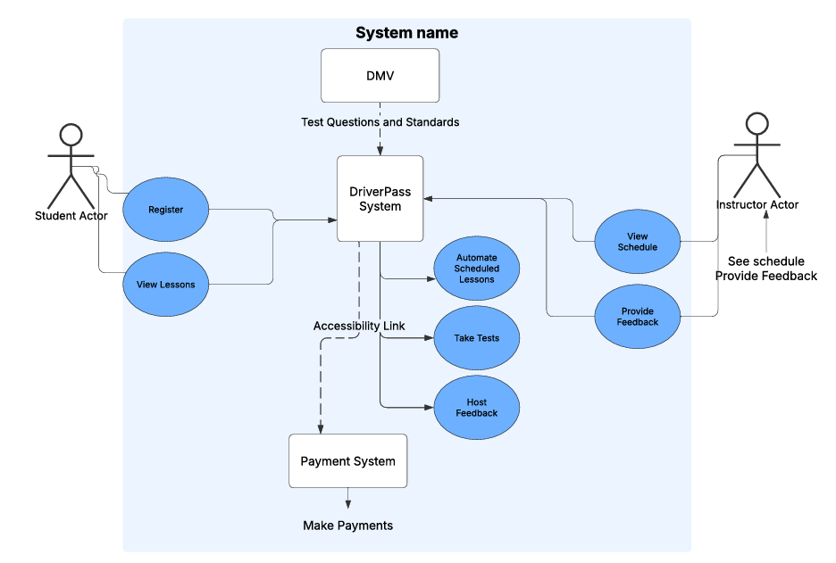

UML Activity Diagrams
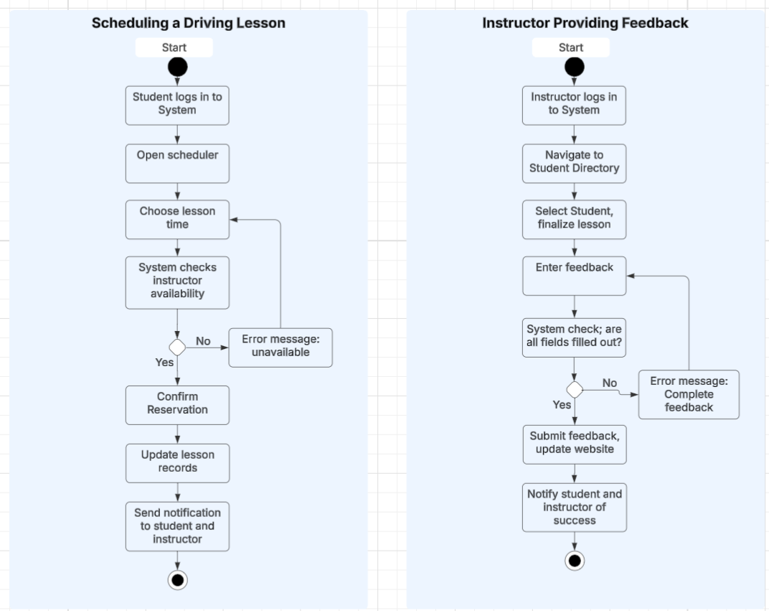

UML Sequence Diagram

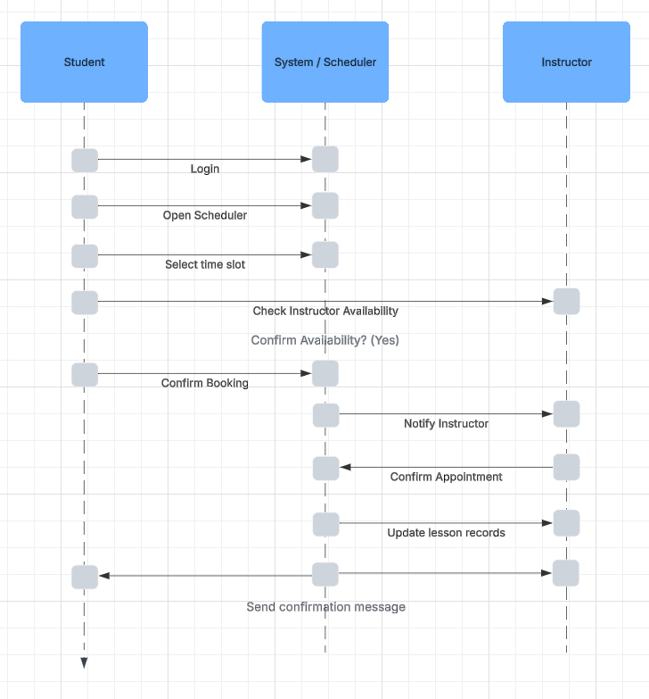

UML Class Diagram
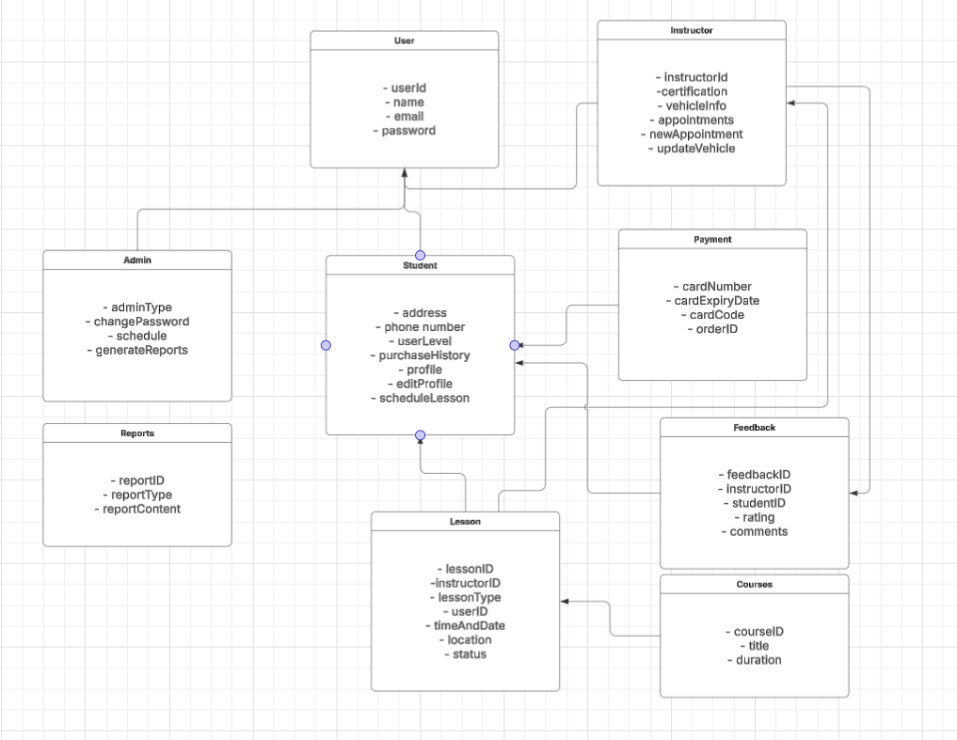

Technical Requirements

Hardware (Host)
- At least one dedicated server for hosting the system
- Backup storage in case of crash, server instability
- Computer interface
- Internet service provider with adequate service plan
Hardware (Client)
- Internet connected device (Computer, laptop, cellphone)
- Internet service
- Consistent power source
- Devices must be compatible with accessibility features
Software (Host)
- Server operating system to host DriverPass
- Security software for sensitive data
- Payment processing software or host
- Server must be capable of handling database queries to maintain 2-5 second response time
Software (Client)
- Web browser for accessing DriverPass, running appropriate web browser.
Development Tools
- Computers with capability to run programming and database software
- Internet access for updates, email and version control
- Monitoring tools for system performance and security
Tools and services
- Vehicles owned by Instructors or Students
- Insurance for instructors and students

